**Crowdfunding Analysis Report**

1. **Given the provided data, what are three conclusions that we can draw about crowdfunding campaigns**?

**C1**. The Crowdfunding campaign has revealed that there is a noticeably higher number of successes in the parent category of theater and the sub-category of plays as compared to the remaining category’s. However, there is a noticeably higher number of failures.

Figure 1.

Figure 2.

**C2.** The analysis has shown that the entertainment field has a higher overall success rate in film/video, music, and theater. This may be due to the entertainment field yielding readily accessible venues.

Table 1.



**C3.** The analysis has revealed that the success rate increased 21% from May to July. The entertainment field of film/video, music, and theater being the major contributor. This may be due to the summer months when entertainment venues flourish.

Figure 3.

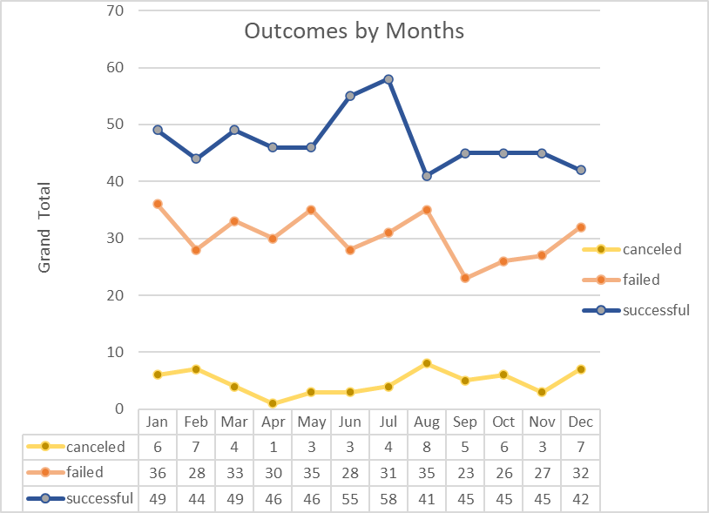

1. **What are some limitations of this dataset?**
2. The provided data set is too small of sample size to obtain an in-depth assessment of a practice that is used worldwide.
3. The data collected from various Crowdfunding platforms may vary in quality and formatting
4. The currency across the country is listed in US dollars. Unknown if currency exchange rates were applied to obtain true dollar value.
5. **What are some other possible tables and/or graphs that we could create, and what additional value would they provide?**

Outside of the requested tables/graphs used in this analysis, the following chart could be used for the analysis:

* Area plot
* Stack area plot

Thsese plots provide a beneficial to the analsysists in the visualization of the volume of data as it changes over time.